op of Form
T

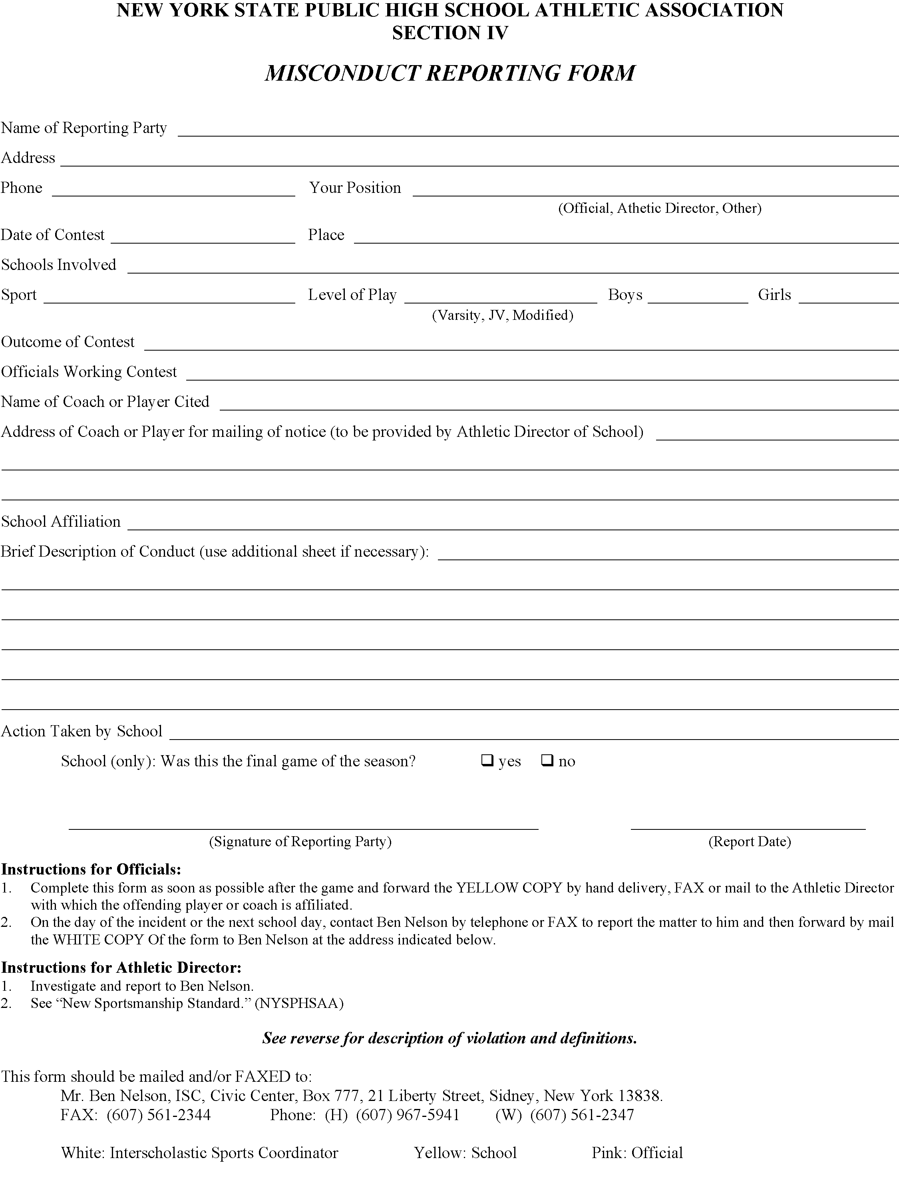

Bottom of Form

